Artificial Intelligence and Machine Learning
Assignment 04
Module 05
Name: Kiran T
Reg No.: 23BECS132

- Explain the K-Nearest Neighbors (KNN) algorithm and implement it using Python on the Iris dataset.
Ans:
K-Nearest Neighbors (KNN) is a supervised machine learning algorithm used for classification and regression tasks. It classifies a new data point based on the majority class of its K nearest neighbors in the feature space.
Working Principle:
- Choose K – the number of neighbors to consider (e.g., 3, 5, 7).
- Calculate distances – compute the distance between the new point and all training points. Commonly used distance metric: Euclidean distance:
$$d(x_{i},x_{j})=\sqrt{\sum_{k=1}^{n}{}(x_{ik}-x_{jk})^{2}}$$
- Find K nearest neighbors – select the K training points with the smallest distance.
- Assign class – the majority class among these neighbors becomes the predicted class for the new point.

- Distance metrics like Euclidean distance are commonly used.
- Pros: Simple, effective for small datasets.
- Cons: Computationally expensive for large datasets, sensitive to noisy data.
Python Code:
from sklearn.datasets import load_iris
from sklearn.model_selection import train_test_split
from sklearn.neighbors import KNeighborsClassifier
from sklearn.metrics import accuracy_score

# Load dataset
iris = load_iris()
X = iris.data
y = iris.target

# Split into train and test
X_train, X_test, y_train, y_test = train_test_split(X, y, test_size=0.2, random_state=42)

# Create KNN model
knn = KNeighborsClassifier(n_neighbors=3)
knn.fit(X_train, y_train)

# Predict and evaluate
y_pred = knn.predict(X_test)
print("KNN Accuracy:", accuracy_score(y_test, y_pred))

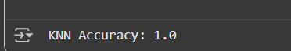

- Describe Gradient Descent and apply it to Linear Regression.
Ans:
Gradient Descent is an optimization algorithm used to minimize a cost function. In machine learning, it is widely used to find the optimal parameters (weights) of models like Linear Regression, Logistic Regression, and Neural Networks.
Working Principle:
- Initialize parameters – start with random values for weights (θ).
- Compute predictions – calculate the predicted outputs using the current parameters.
- Calculate cost function – commonly, Mean Squared Error (MSE) for Linear Regression:
$$J(θ)=\frac{1}{2m}\sum_{i=1}^{m}{}(h_{θ}(x_{i})-y_{i})^{2}$$
where $h_{θ}(x_{i})=θ_{0}+θ_{1}x_{i}$is the predicted value.
4. Compute gradients – partial derivatives of the cost function with respect to each parameter:
$$\frac{∂J(θ)}{∂θ_{j}}=\frac{1}{m}\sum_{i=1}^{m}{}(h_{θ}(x_{i})-y_{i})x_{ij}$$
- Update parameters – move in the direction opposite to the gradient:
$$θ_{j}:=θ_{j}-α\frac{∂J(θ)}{∂θ_{j}}$$
where α is the learning rate, $J(θ)$= cost function.
6. Repeat steps 2–5 until convergence (cost function stops decreasing significantly).

Python Code:
import numpy as np
import matplotlib.pyplot as plt

# Generate synthetic data
np.random.seed(0)
X = 2 * np.random.rand(100, 1)
y = 4 + 3 * X + np.random.randn(100, 1)

# Add bias term
X_b = np.c_[np.ones((100,1)), X]

# Initialize parameters
theta = np.random.randn(2,1)
alpha = 0.1
iterations = 1000

# Gradient Descent
for i in range(iterations):
gradients = 2/100 * X_b.T.dot(X_b.dot(theta) - y)
theta -= alpha * gradients

print("Learned parameters:", theta)

# Plot
plt.scatter(X, y)
plt.plot(X, X_b.dot(theta), color='red')
plt.show()
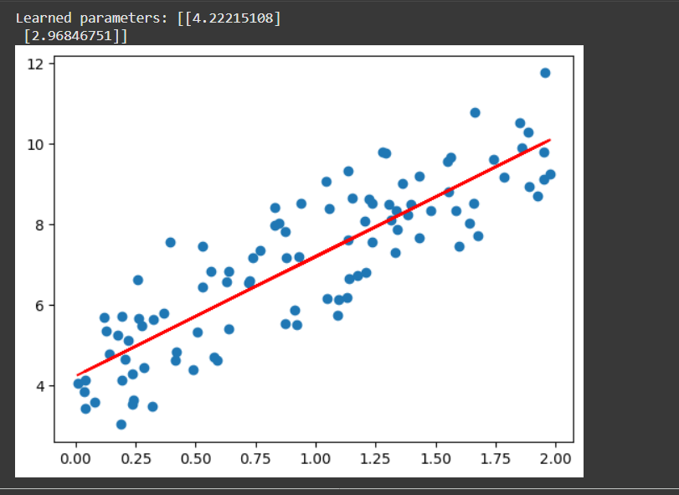

- Explain the Mean Squared Error (MSE) cost function for Linear Regression and compute it for a sample dataset.
Ans:
Mean Squared Error (MSE) is a cost function used in regression tasks to measure the average squared difference between predicted values and actual target values. It evaluates how well a regression model fits the data.
- For a dataset with $n$data points, compute the predicted values ${\hat{y}}_{i}$using the model:
$${\hat{y}}_{i}=θ_{0}+θ_{1}x_{i}$$
- Calculate the difference (error) between the predicted value ${\hat{y}}_{i}$and the actual value $y_{i}$.
- Square the error to penalize larger deviations.
- Take the mean of all squared errors to get MSE:
$$MSE=\frac{1}{n}\sum_{i=1}^{n}{}(y_{i}-{\hat{y}}_{i})^{2}$$
Interpretation:
- Lower MSE → model predictions are closer to actual values.
- Penalizes larger errors more due to squaring.
- Commonly used in Linear Regression to optimize parameters via Gradient Descent.
Advantages:
- Simple and widely used metric for regression.
- Differentiable, making it suitable for optimization.
Disadvantages:
- Sensitive to outliers because errors are squared.

Python Code:
import numpy as np

# Sample data
X = np.array([1, 2, 3, 4, 5])
y = np.array([5, 7, 9, 11, 13])
theta0, theta1 = 3, 2

# Predictions
y_pred = theta0 + theta1 * X

# Compute MSE
mse = np.mean((y - y_pred)**2)
print("Mean Squared Error:", mse)
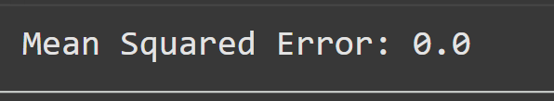

- Describe Support Vector Machine (SVM) and implement a classifier using Python.
Ans:
Support Vector Machine (SVM) is a supervised machine learning algorithm used for classification and regression tasks. It works by finding an optimal hyperplane that separates data points of different classes with the maximum margin.
- Identify Support Vectors: These are the data points closest to the decision boundary (hyperplane).
- Maximize the Margin: The hyperplane is chosen such that the distance (margin) between support vectors of different classes is maximized.
- Linear vs Non-Linear SVM:
  - Linear SVM: Data is linearly separable; uses a straight hyperplane.
  - Non-linear SVM: Data is not linearly separable; uses kernel functions (RBF, polynomial, sigmoid) to transform data into higher dimensions for separation.
Mathematical Representation:
- For linearly separable data, SVM solves:
$$\text{minimize }\frac{1}{2}∥w∥^{2}\text{subject to }y_{i}(w⋅x_{i}+b)≥1,∀i$$
where $w$= weight vector, $b$= bias, $y_{i}$= class label (+1/-1), $x_{i}$= feature vector.

Advantages:
- Works well in high-dimensional spaces.
- Effective when the number of features > number of samples.
- Robust to overfitting with proper regularization.
Disadvantages:
- Not suitable for very large datasets (high computational cost).
- Performance depends on choice of kernel and hyperparameters.

Python Code:
from sklearn.datasets import load_iris
from sklearn.model_selection import train_test_split
from sklearn.svm import SVC
from sklearn.metrics import accuracy_score

# Load dataset
iris = load_iris()
X = iris.data
y = iris.target

# Split into train and test
X_train, X_test, y_train, y_test = train_test_split(X, y, test_size=0.2, random_state=42)

# SVM model
svm_model = SVC(kernel='linear')
svm_model.fit(X_train, y_train)

# Predict and evaluate
y_pred = svm_model.predict(X_test)
print("SVM Accuracy:", accuracy_score(y_test, y_pred))
